
www.globalsight.com

GlobalSight Web Services APIs
Open source initiative for
managing, translating &
delivering global content
Test Tool（Java）

Version 1.0

@Welocalize and Li Kun(Peking University)

Overview
This tool is used for testing GlobalSight Web Service APIs.

Install
Extract to local folder. Then run run.bat.

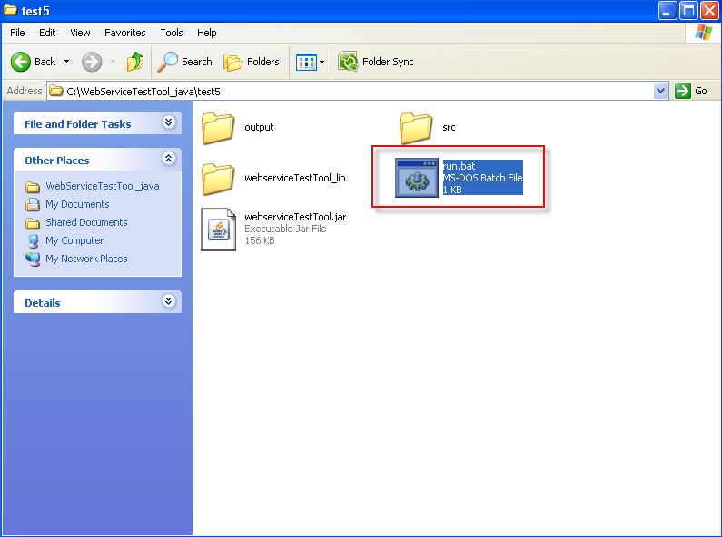

Login
Input the IP address or host name, port, username, password, and select https if the server is running https. Then click login.

Also user can select the history account in the left panel, and user can reset, add, or delete account.

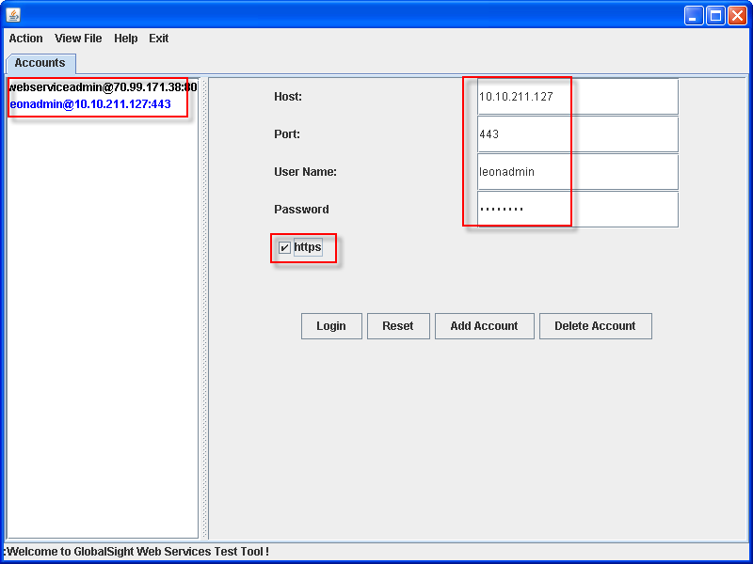

Test
If logon successfully, user can start testing the APIs that GlobalSight offered. All the APIs are listed in the left panel.

First user need select a method in the left panel, then all the parameters of this method are listed in the right panel, user can input the parameters according to the type of them and the data in the database of GlobalSight System. After that, click test, then the results are output at the bottom panel. User can check if the result is wanted.

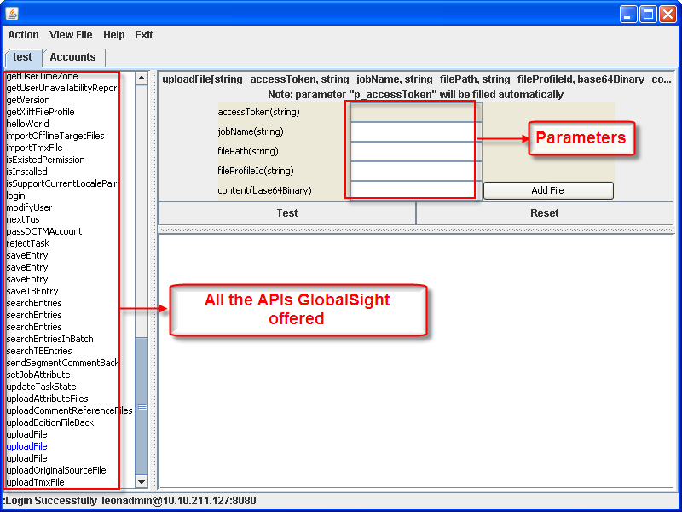

Notes:
- HashMap as parameter or java specified object as returned value (not supported):

Some APIs take HashMap as parameters, and these APIs are not supported by this tool for now.

For example,
void createJob(HashMap args)

void createEditionJob(HashMap args)

HashMap searchEntriesInBatch(String, Long, Map, Long, Map, Boolean, Boolean),

void setJobAttribute(String, long, String, Object)

TimeZone getUserTimeZone(String p_accessToken, String p_userId)

- Parameters that can be null

For some APIs, some parameters of them can be null. In this case, user can keep them empty. For example,

String getTasksInJob(String p_accessToken, long p_jobId, String p_taskName)
p_taskName can be null.

- Array as parameter

Some APIs have String[]( arrayof_soapenc_string) as parameter. In this case, user can input parameter value like this:
<value1>,<value2>,<value3>,…

- FilePath as parameter

Some methods have filepath as parameter. User can input as below: \aa.html
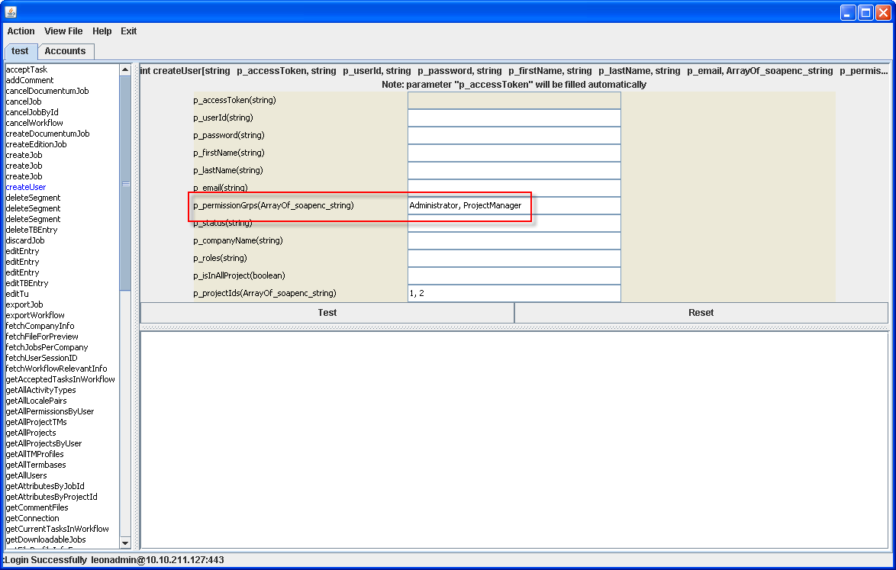

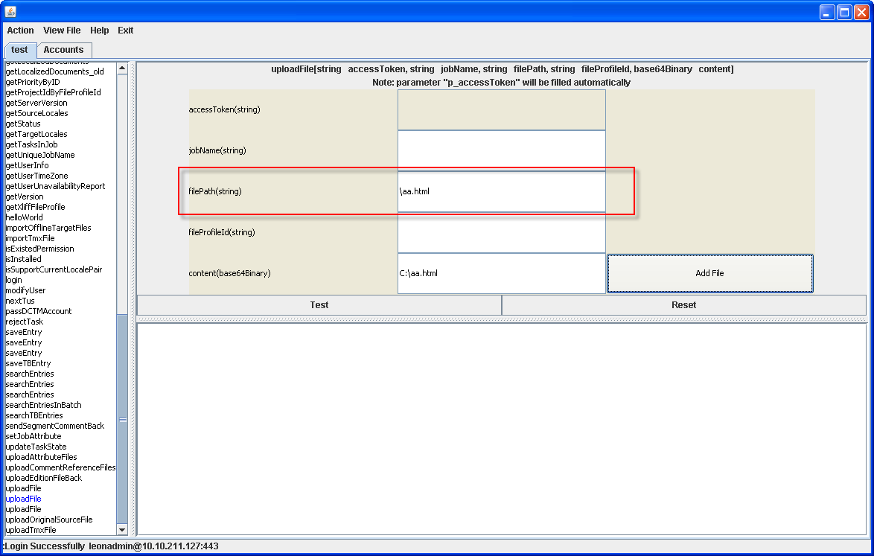

Update
Once GlobalSight web service APis are changed, we will update this testing tool to catch the changes on server.

So you may run into situation that certain APIs fail to run on a newly updated server which contains newly added APIs or changed APIs.

